Batman

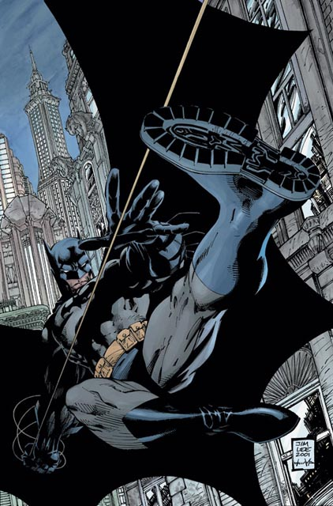
Real Name: Bruce Wayne

Occupation: businessman

Height: 6’ 2”

Weight: 210 lbs.

Abilities

Indomitable Will: Although he has no superhuman powers, Batman's unstoppable determination and strength of will make him an extremely formidable opponent. This makes him able to function while tolerating massive amounts of physical pain, and also allows him to resist telepathy or mind control. His willpower is strong enough to operate a Green Lantern Ring when necessary.

Intimidation: It is widely known that Batman has the ability to instill fear in others, even the people that know him best are intimidated by him. Even those who aren't afraid of the likes of Superman fear Batman. His ability to inspire great fear made him eligible for induction into the Sinestro Corps, although he was able to fight off the power ring's control.

Interrogation: Batman is adept in interrogation techniques, often using law enforcement methods as well as torture. Several methods seen include hanging a person over the edge of a building by one leg or chaining a person upside down and beating them. He usually just plain uses his frightening appearance to get answers. "Fear is an excellent motivator" he once said.

Peak Human Conditioning: Through intense training, specialized diet, and biofeedback treatments, Batman represents the pinnacle of human physical prowess. His physical attributes exceeded that of any Olympic level athlete that has ever completed. Strength, speed, stamina, agility, reflexes and coordination are at peak human perfection. Batman began his physical and mental conditioning when he was 11 and then intense physical training and weight lifting at age 12. He has mastered full body control by the time he was 18. Bruce Wayne, since the age of 15, has created a strict diet to enable his body to develop and operate at its most proficient, along with biofeedback treatments (using portable/non portable machines to stimulate muscles to contraction). Batman has performed amazing physical feats due to his superior physique. He engaged in an intensive regular regimen of rigorous exercise (including aerobics, weight lifting, gymnastics, and simulated combat) to keep himself in peak condition, and has often defeated opponents whose size, strength, or other powers greatly exceeded his own. He has spent his entire life in pursuit of physical perfection and has attained it through constant intensive training and determination.

Peak Human Strength: Batman regularly bench-presses at least 1000 lbs. during his exercise routine.

Peak Human Reflexes: Bruce's reflexes were honed to such a degree that he has caught one of Green Arrow's arrows in mid-flight when he tried to shoot him. He has also been able to dodge point blank gunfire.

Peak Human Speed: He could run at speeds comparable to the finest competing athletes.

Peak Human Endurance: His endurance was comparable to that of the finest Olympic Decathlon participant. His lung capacity was so great that he could hold his breath underwater for 3 minutes and 15 seconds. He can survive in the airless vacuum of space for exactly 27 seconds.

Peak Human Agility: His agility was greater than that of a Chinese acrobat and an Olympic gold medalist gymnast. His main phase of movement was Parkour which he learned in France and used that to scale the cities rooftops in an acrobatic manner.

Acrobatics: He is proficient in gymnastics and acrobatics.

Martial Arts: Bruce is well trained in multiple martial arts, he is known as the man who has mastered 127 forms of martial arts. His primary form of combat is an idiosyncratic admixture of Tae Kwon Do,Judo, Muay Thai, Dragon Style Kung Fu, Boxing, Jujitsu, Ninjitsu and Capoeira.

Weaponry Through his martial arts training, he has become an expert on all melee weapons. Wayne has displayed exceptional sword fighting capability and proficiency with knives, sticks and various other weapons. He practices during his combat sessions to keep his skills intact, but he prefers unarmed combat.

Stealth: His Ninjutsu training has made him a master at stealth and capable of breaching high security facilities without being detected.

Marksmanship: Wayne is an expert marksman skilled. He is skilled with throwing projectile weapons, archery and firearms. He has been practicing such skills since the early days of his training and is almost on par with the Green Arrow in terms of accuracy.

Genius Level Intellect: Batman is a brilliant, virtually peerless, detective, strategist, scientist, tactician, and commander; he is widely regarded as one of the keenest analytical minds on the planet. Given his lack of superpowers, he often uses cunning and planning to outwit his foes, rather than simply "out-fighting" them. Additionally, he has studied Biology, Technology, Mathematics, Physics, Mythology, Geography, & History. He has gained degrees in Criminal Science, Forensic sciences, Computer Sciences, Chemistry and Engineering by the time he was 21. He gained even more degrees in Biology, Physics, Advanced Chemistry, and Technology by the time he was 25.

Investigation: He is widely considered as the World's Greatest Detective, capable of observation, forensic investigation, and inductive and deductive reasoning of the highest caliber. Human intuition is an unlearnable trait and one of Batman's most effective tools. Given any mystery, he can arrive at the correct conclusions with a fraction of the data.

Tactical Analysis: He commonly utilizes cunning tactics to outwit his foes. He is an excellent leader and at times commands the Justice League and the Outsiders, Batman is known as one of the greatest strategists and tacticians in the dc universe, and once even Aquaman stated the same.

Driving: Bruce is proficient at driving many vehicles like cars, motor bikes, trucks and he is also skillful at driving jets, helicopters and auto boats and small ships.

Disguise: Has mastered the art of disguise by the time he was 23.

Business Management: Bruce Wayne has extensive skills and experience in business management, has thorough understanding of financial marketing and management and is often known as a example of successful industrialist and businessman on par to Lex Luthor.

Equipment

Batsuit: The costume Batman wears is composed of reinforced Kevlar and a little percentage of titanium; it's bullet-proof and resistant to various types of attack (explosions, impacts, falls, etc...). It's also flame-retarding and insulating. The gloves and the boots are reinforced to rebound the impact of punches and kicks. The gloves have also some metallic blades on their sides. The cape is designed to provide the wearer with controlled gliding functionality with the ability to change directions and heights while in mid-air. The mask has a little percentage of lead, which shields the face of Batman from x-ray powers or x-ray technology, and incorporates an infrared and night visor, auditory sensors and a sonar. The mask is accessorized with some security systems (aggravating gas, electric blasts, etc.), like the utility belt, and integrates a transmitter receiver device de voice and video.

Utility Belt: Batman keeps most of his personal field equipment in a signature piece of apparel, a yellow utility belt. The utility belt has a button to call the car in a few appearances on Justice League, and a command for teleportation. Over the years it has contained items such as plastic explosives, nerve toxins, batarangs, smoke bombs, a fingerprint kit, a cutting tool, a grappling hook gun, torches, a "re-breather" breathing device, and lock picks. Superman had entrusted Batman with a ring made of kryptonite, to be used should the Man of Steel ever need to be reined in (due to being mind-controlled by a villain, etc.). The Kryptonite Ring is contained in a lead pocket, in order to shield Batman from its radiations. The belt has also its own automatic security systems.

Transportation: Batboat, Batcycle, Batmobile, and Batplane

source: http://dc.wikia.com/wiki/Batman_(Bruce_Wayne)

